NCM/Care Coordination Best Practice Sharing

Agenda
 | Date: Tuesday, 12 20 16 Start/End Time: 8:00 – 9:30 am
Location: 301 Metro Center Blvd 2nd Floor, Warwick RI Call in number: 508-856-8222 Code: 2525 (Host: 2116)
Go to Meeting: https://global.gotomeeting.com/join/434985861

Meeting Information: |  |  |  | CTC Management and Speakers
Meeting Purpose/Objective: Best practice sharing amongst CTC Care Managers :  PARTNERING WITH COMMUNITY-BASED ORGANIZATIONS TO SUPPORT HEALTH  Attachments:  PowerPoints: “RI Home and Community Care Services to the Elderly” and “LogistiCare Rhode Island”; and related documents: Municipal Transportation, Healthy Leads – Screening Toolkit, Eligibility Guidelines, Senior Facts, SNAP-shot Medical Expenses Deductions, Automated Information Line, Someone You Know, and Request Form |  |  |  | Deb Hurwitz, CTC  Pano Yeracaris, CTC  Susanne Campbell, CTC  Candice Brown, CTC  Maureen Maigret  Sue Jameson | Robin Knoderer  Kathleen McKeon  Annie Murphy  Pamela Jennings
Annie Murphy
Pamela Jennings
Marie Padilla
Heather Amaral

Why it Matters?

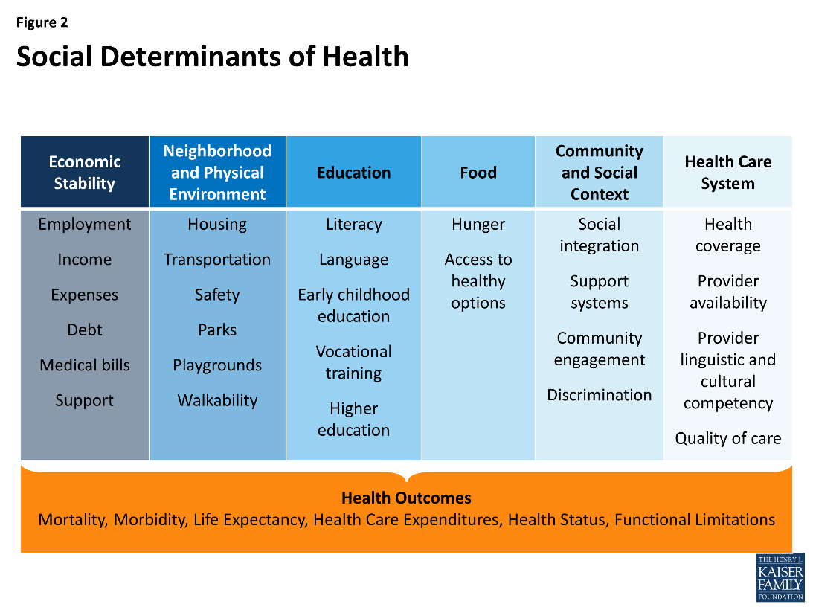

Health Care’s Blind Side:
The Overlooked Connection between Social Needs and Good Health

“There is strong evidence linking social needs to health and life expectancy. Health care itself plays a surprisingly small role (10 percent of contributing factors) in life expectancy. Social circumstances, environmental exposure and behavior are estimated to account for 60 percent of the risk of premature death.

- 4 in 5 (85%) say unmet social needs are directly leading to worse health

- 4 in 5 physicians surveyed (85%) say patients’ social needs are as important to address as their medical conditions.

- 4 in 5 physicians surveyed (80%) are not confident in their capacity to address their
patients’ social needs

Physicians wish they could write prescriptions to help patients with social needs
Fitness program - 75%, nutritional food - 64%, Transportation assistance - 47%

# | Owner | Topic | Notes
1 | Susanne Campbell  5 minutes | Welcome  - Introductions  - Review agenda
2 | Maureen Maigret  15 minutes | RI Home and Community Care Services to the Elderly
3 | Kathleen McKeon  Diocese of Providence  15 minutes | Overview of Catholic Social Services Care Breaks Program, respite care and support for caregivers
 | Robin Knoderer  LogistiCare  15 minutes | LogistiCare Rhode Island
 | Annie Murphy  Alzheimer’s Association  15 minutes | RI Alzheimer’s Association
 | Pamela Jennings  URI SNAP  15 minutes | SNAP
Sue Jameson
South County Hospital

 | Heather Amaral
 | Group Discussion  10 minutes | Panel Discussion
4 |  | Next meeting  1/17/17 - 8AM at 301 Metro Center Blvd

ACTION ITEM LOG
Added | Ref. # | Assignee | Action /Status | Due | Closed

summary of findings from a Robert Wood Johnson Foundation survey of physicians survey of america’s physicians http://www.rwjf.org/content/dam/farm/reports/surveys_and_polls/2011/rwjf71795

