Instructions for Obtaining NCQA Value Set Spreadsheet

- Navigate to the NCQA website. (If clicked from electronic copy of this document, you will navigate directly to the value set page)
- Choose “Add to Cart”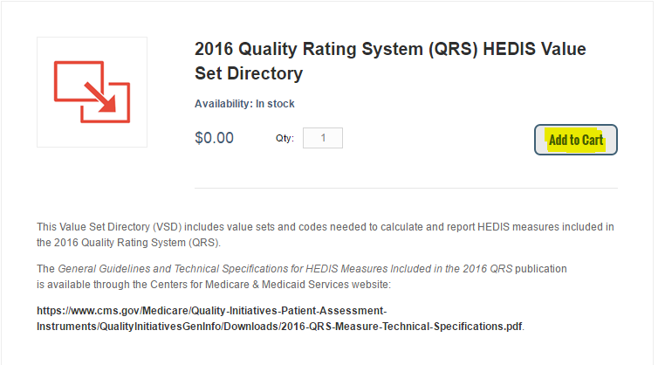
- Navigate to “Check Out.” First time users will be prompted to create an account. After doing so log in as requested.
- Once you have logged in, return to check out and select “Ship to this address”
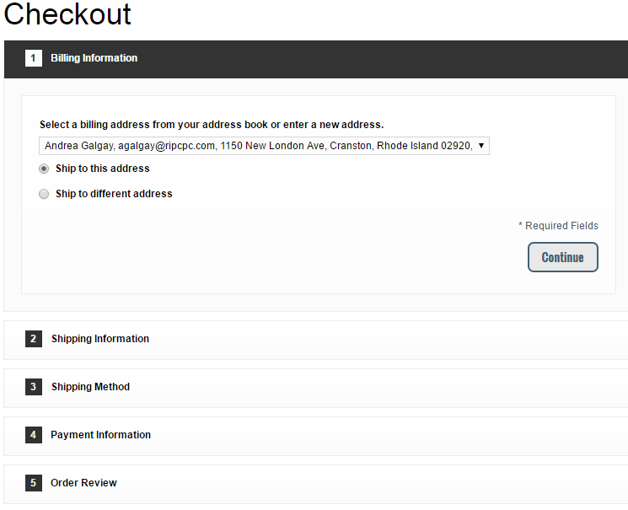

- Documents will be emailed to you in a few minutes. It initially appears like they are going to send you a hard copy, but it comes electronically.
- Once downloaded, navigate to the sheet entitled “QRS Value Sets to Codes.”
- Filter by Value Set Name to populate the sheet with only those you need (e.g. Pregnancy Value Set).

