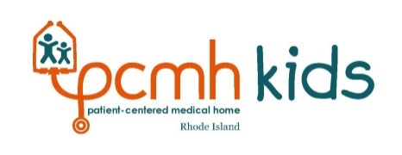

PCMH-Kids Behavioral Health Learning Collaborative
AGENDA

April 26, 2017

Shriner’s Imperial Room at 1 Rhodes Place, Cranston, RI

7:00-7:30am | Breakfast and Registration
7:30-7:45am | Welcome and Introductions  Speaker  - Patricia Flanagan, MD, Hasbro Pediatric Primary Care Clinic and PCMH-Kids Co-Chair
7:45-7:55am | New Resource Tools for ADHD Care  Speakers  - Elizabeth Cantor, Ph.D (Director of Outpatient Behavioral Health, CharterCARE Health Partners); and  - Debra Lobato, Ph.D (Director of Integrated Care and Director of Child Psychology at Rhode Island and Hasbro Children’s Hospitals. Professor (Clinical) Departments of Psychiatry and Pediatrics at Alpert Medical School of Brown University)
7:55-8:25am | ADHD Project Story Board Review  The six practices that participated in the ADHD learning collaborative will have a few minutes to showcase their project and story board.
8:25-8:50am | Practice Group Story Board Review  Practices representatives will have time to walk around, view other practices story board and ask questions.
8:50-9:00am | Break
9:00-10:00am | Screening for Postpartum Depression: Why Pediatricians Matter  Facilitator  - Patricia Flanagan, MD, Hasbro Pediatric Primary Care Clinic and Co-Chair PCMH-Kids  Speaker  - Margaret Howard, Ph.D., Professor of Psychiatry and Human Behavior and Medicine
10:00-10:20am | American Academy of Pediatrics (AAP) Perspective on Post-Partum Depression Screening Presentation  Speaker  - Elizabeth Lange, MD, Coastal Waterman Pediatrics and Co-Chair PCMH-Kids
10:20-11:00am | Facilitated Team Time  Participants will sit with their practice team to articulate their learning collaborative focus area and aim statement. Practice facilitators will be present to help practices create a plan of action so that practices will leave with concrete action steps and a clear idea of their continuous quality improvement cycles.
11:00-11:45am | Aim Statement Report Out  Participants will report out on the work completed with their practice teams on their aims statements.
11:45am-12pm | Wrap Up  Speakers  - Patricia Flanagan, MD, Hasbro Pediatric Primary Care Clinic and Co-Chair PCMH-Kids; and  - Elizabeth Lange, MD, Coastal Waterman Pediatrics and Co-Chair PCMH-Kids
12:00pm | Lunch  Participants will be provided a lunch they may take with them or stay and network.

