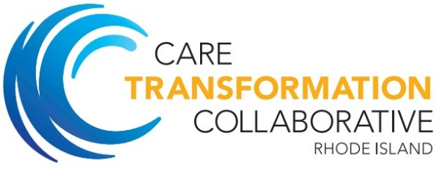

PCMH-Kids Behavioral Health Learning Collaborative
AGENDA

April 27, 2016

Shriner’s Imperial Room at 1 Rhodes Place, Cranston, RI

7:00-7:30am | Breakfast and Registration
7:30-7:40am | Welcome and Introductions  Speaker  - Patricia Flanagan, MD, Hasbro Pediatric Primary Care Clinic and Co-Chair PCMH-Kids
7:40-8:05am | Best Practice Protocols for ADHD  In this session, a child and adolescent psychiatrist will review best practice protocols for ADHD diagnosis, treatment, goal-setting, follow-up, and medications as promoted by the American Academy of Pediatrics and the National Institute for Children’s Health Quality.  Speaker  - Elizabeth Lowenhaupt, MD, President of Rhode Island Council for Child and Adolescent Psychiatry
8:05-9:50am | Case Presentation and Panel Discussion  In this session, a panel of experts will be presented with multiple case examples of ADHD-related issues that are seen in primary care. Through these case examples, panelists will discuss:  - Practical application of best practices in primary care  - How to start and monitor medications as well as non-pharmacological strategies for managing ADHD, incorporating issues of substance use  - Multigenerational dynamics of ADHD  - RI-specific resources  Facilitator  - Patricia Flanagan, MD, Hasbro Pediatric Primary Care Clinic and Co-Chair PCMH-Kids  Speaker  - Richard Archambault, M.S., Ed.D, Lifespan Cedar for Care Coordination  - Donna Barré, PhD, AAC, ADHD Coach and research consultant  - Lisa Conlan-Lewis, Executive Director, Parent Support Network  - Elizabeth Lowenhaupt, MD, President of Rhode Island Council for Child and Adolescent Psychiatry  - Shana Maher, consumer advocate  - Mary Murray, MD, Coastal Narragansett Bay Pediatrics  - Kelly Robinson, PhD, PCC, Children and Adults with Attention-Deficit/Hyperactivity Disorder (CHADD) and ADHD Life Skills
9:50-10:00am | Break
10:00-11:45am | Facilitated Team Time  Participants will sit with their practice team to articulate their learning collaborative focus area and problem statement. Practice facilitators will be present to help practices create a plan of action so that practices will leave with concrete action steps and a clear idea of their continuous quality improvement cycles.
11:45am-12pm | Wrap Up  Speaker  - Nelly Burdette, PhD, Providence Community Health Centers and Care Transformation Collaborative
12:00pm | Lunch  Participants will be provided a bagged lunch they may take with them or stay and network

