MAPCP Portal
This is the portal for practices who participate in the Multi-Payer Advanced Primary Care Practice (MAPCP) Demonstration, the Centers for Medicare & Medicaid Services (CMS). All practices that entered the CTC-I Program prior to 2013 are participants in the MAPCP Demonstration project.
MAPCP Portal Login: https://mapcp.rti.org/
CTC-RI MAPCP Portal Contact Information
Michele Brown, Project Coordinator
CTC-RI Project Team, 508-421-5919
michele.brown@umassmed.edu
MAPCP Home Page
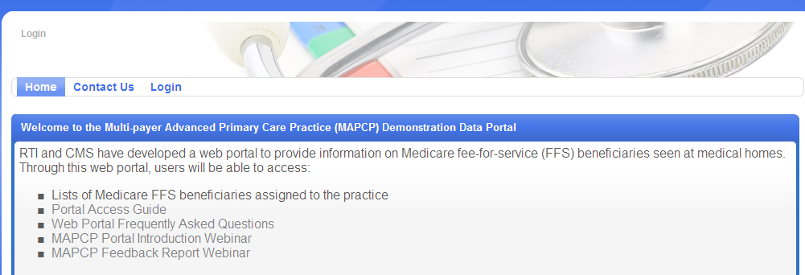

Technical Assistance
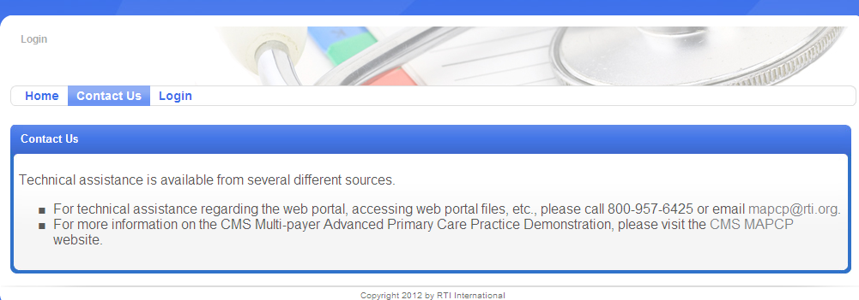

LOGIN Page
If you have forgotten your password, click the Forgot Password button and you will be sent at Password reset email to your registered email address.
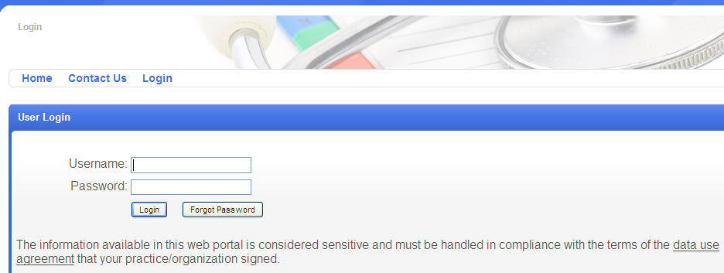
Date Portal Main Page
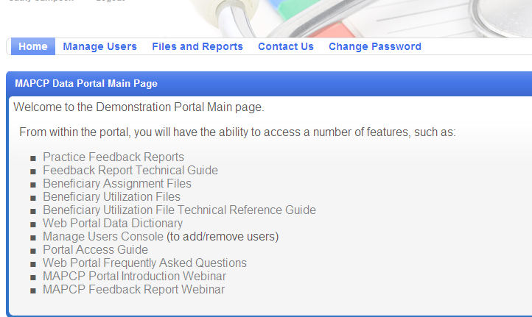
Files and Reports
Each practice will only have access to view their own practice data.
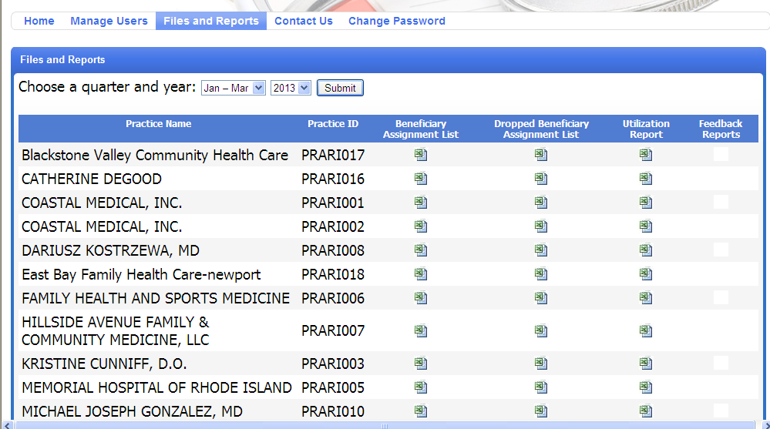

Reports include:
- Beneficiary Assignment Lists
Data Fields:
Patient ID | MI | HIC
New Patient | Zip | Practice ID
Last Name | County | Medical Home
First Name | DOB | CHO ID
Address | Gender | CHO Name

- Dropped Beneficiary Assignment Lists
Data Fields:
Patient ID | Zip | Practice ID
Last Name | County | Medical Home
First Name | HIC | CHO ID
MI | DOB | CHO Name
Address | Gender
- Beneficiary Utilization Reports
Data Fields:
Patient Number | Chest Pain | Discharge date of 4th  Hospitalization
Last Name | Spondylosis/Other Back Problems | Facility of 4th Hospitalization
First Name | COPD or Bronchiectasis | Principal Diagnosis  4th Hospitalization
Age | Urinary Tract Infection | ACSC Admission 4th  Hospitalization
DOB | Pneumonia | Discharge date of 5th  Hospitalization
Gender | Congestive Heart Failure | Facility of 5th Hospitalization
HCC Category | Inpatient Expenditures | Principal Diagnosis 5th Hospitalization
Claims based diagnosis  of diabetes | Specialty Provider Expenditures | ACSC Admission 5th  Hospitalization
HbA1C Test | Primary Care Provider Expenditures | Discharge  date of 6th  Hospitalization
Date of HbA1C Test | ER Expenditures | Facility of 6th Hospitalization
Hba1c done by practice | Number of  Hospitalizations | Principal Diagnosis 6th Hospitalization
LDL-C Test | Discharge date of 1st  Hospitalization | ACSC Admission 6th  Hospitalization
Date of LDL-C Test | Facility of 1st Hospitalization | Number of ER visits
LDL-C done by Practice | Principal Diagnosis  1st Hospitalization | Date of 1st ER visit
Eye Exam | ACSC Admission 1st  Hospitalization | Facility of 1st ER visit
Eye Exam done by practice | Discharge date of 2nd  Hospitalization | Principal Diagnosis 1st ER visit
Nephropathy | Facility of 2nd Hospitalization | Date of 2nd ER visit
Date of Nephropathy  Screening | Principal Diagnosis  2rd Hospitalization | Facility of 2nd ER visit
Nephropathy Screening  done by practice | ACSC Admission 2nd  Hospitalization
Claims based diagnosis of Heart Disease | Discharge date of 3rd  Hospitalization
Complete Lipid Panel | Facility of 3th Hospitalization
Date of Complete Lipid Panel | Principal Diagnosis  3rd Hospitalization
Lipid done by practice | ACSC Admission 3rd  Hospitalization
- Practice Feedback Reports
The Feedback Report Technical Guide on the Home Page provides information regarding the Feedback Report.

